PostgreSQL DB Recommendation Document

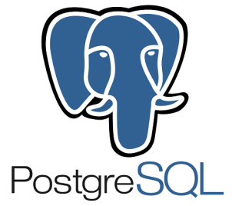

Product Description:
PostgreSQL is an open source object-relational database system.

- It runs on all major operating systems, including Linux, UNIX (AIX, BSD, HP-UX, SGI IRIX, Mac OS X, Solaris, Tru64), and Windows.
- It is fully ACID compliant, has full support for foreign keys, joins, views, triggers, and stored procedures (in multiple languages).
- It includes most SQL:2008 data types, including INTEGER, NUMERIC, BOOLEAN, CHAR, VARCHAR, DATE, INTERVAL, and TIMESTAMP.
- It also supports storage of binary large objects, including pictures, sounds, or video.
- It has native programming interfaces for C/C++, Java, .Net, Perl, Python, Ruby, Tcl, ODBC, among others.

An enterprise class database, PostgreSQL boasts sophisticated features such as MVCC, point in time recovery, tablespaces, asynchronous replication, nested transactions (savepoints),
Online/hot backups, a sophisticated query planner/optimizer, and write ahead logging for fault tolerance.

It supports international character sets, multibyte character encodings, Unicode, and it is locale-aware for sorting, case-sensitivity, and formatting.
It is highly scalable both in the sheer quantity of data it can manage and in the number of concurrent users it can accommodate.

There are active PostgreSQL systems in production environments that manage in excess of 4 terabytes of data.

Limit Value
Maximum Database Size Unlimited
Maximum Table Size 32 TB
Maximum Row Size 1.6 TB
Maximum Field Size 1 GB
Maximum Rows per Table Unlimited
Maximum Columns per Table 250 - 1600 depending on column types
Maximum Indexes per Table Unlimited

A service-oriented Architecture applied on the Database.

Cluster solution ( Linux/ EDB)

Clustering
- CitusDB - shards and replicates tables across a scalable, high availability cluster of commodity PostgreSQL servers and parallelizes queries for real-time SQL on big data.
- Greenplum Database (formerly Bizgres MPP), proprietary. Not so much a replication solution as a way to parallelize queries, and targeted at the data warehousing crowd. Similar to ExtenDB, but tightly integrated with PostgreSQL.
- GridSQL for EnterpriseDB Advanced Server (formerly ExtenDB)
- HadoopDB - A MapReduce layer put in front of a cluster of postgres back end servers. Shared-nothing clustering.
- PL/Proxy - database partitioning system implemented as PL language.
- pg_shard - extension that shards and replicates table across many servers, can also scale out Amazon RDS
- sequoia (jdbc, formerly known as c-jdbc)

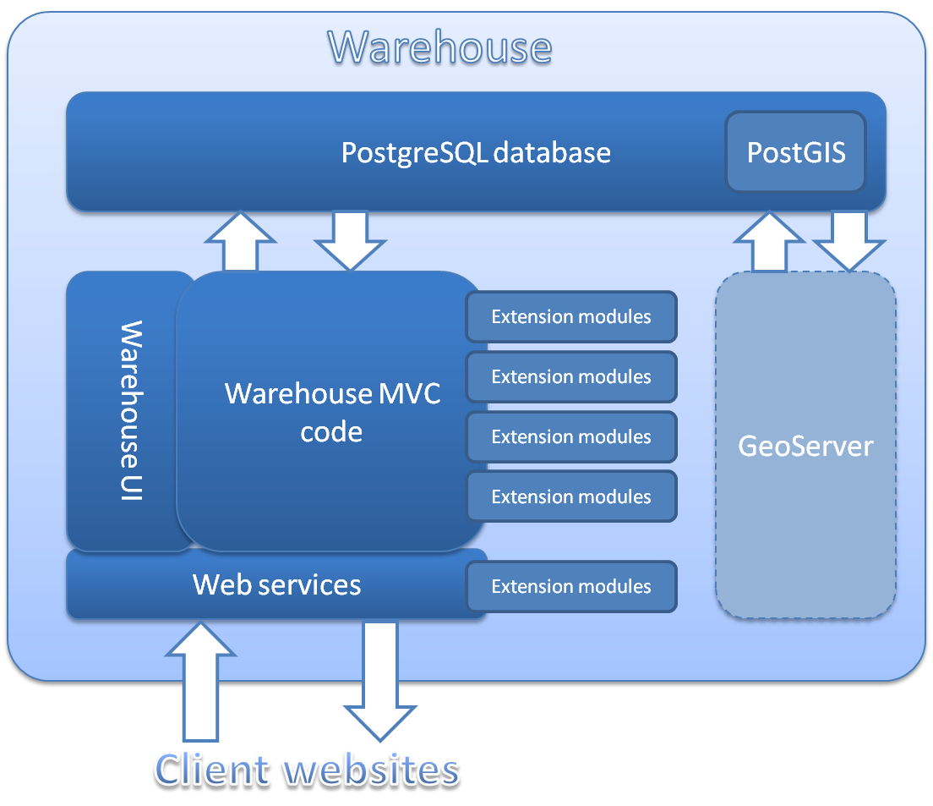

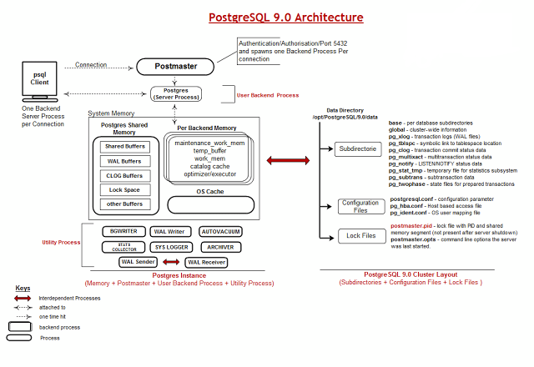
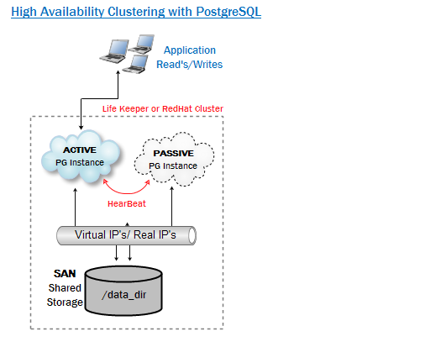

Table partition : http://www.postgresql.org/docs/9.1/static/ddl-partitioning.html
Cluster solution : https://wiki.postgresql.org/wiki/Replication,_Clustering,_and_Connection_Pooling
Storage : http://www.postgresql.org/docs/9.1/static/storage-file-layout.html (information)

Licencing :

PostgreSQL is released under the PostgreSQL License, a liberal Open Source license, similar to the BSD or MIT licenses.

PostgreSQL Database Management System (formerly known as Postgres, then as Postgres95)
Portions Copyright (c) 1996-2015, The PostgreSQL Global Development Group
Portions Copyright (c) 1994, The Regents of the University of California
Permission to use, copy, modify, and distribute this software and its documentation for any purpose, without fee, and without a written agreement is hereby granted, provided that the above copyright notice and this paragraph and the following two paragraphs appear in all copies.

IN NO EVENT SHALL THE UNIVERSITY OF CALIFORNIA BE LIABLE TO ANY PARTY FOR DIRECT, INDIRECT, SPECIAL, INCIDENTAL, OR CONSEQUENTIAL DAMAGES, INCLUDING LOST PROFITS, ARISING OUT OF THE USE OF THIS SOFTWARE AND ITS DOCUMENTATION, EVEN IF THE UNIVERSITY OF CALIFORNIA HAS BEEN ADVISED OF THE POSSIBILITY OF SUCH DAMAGE.
THE UNIVERSITY OF CALIFORNIA SPECIFICALLY DISCLAIMS ANY WARRANTIES, INCLUDING, BUT NOT LIMITED TO, THE IMPLIED WARRANTIES OF MERCHANTABILITY AND FITNESS FOR A PARTICULAR PURPOSE. THE SOFTWARE PROVIDED HEREUNDER IS ON AN "AS IS" BASIS, AND THE UNIVERSITY OF CALIFORNIA HAS NO OBLIGATIONS TO PROVIDE MAINTENANCE, SUPPORT, UPDATES, ENHANCEMENTS, OR MODIFICATIONS.
Why not the GNU General Public License?
The simple answer is because Postgres like thier license and do not want to change it

Pros over MSSQL:

- CSV Support
- PostgreSQL runs in Linux, BSD, Windows …etc
- Complete Procedural language features.
- Native regular expression support
- Custom aggregate functions
- Unicode support
- Full support of Data types
- It’s Opensource

More details & source at http://www.pg-versus-ms.com/
Over Sybase: http://www.postgresql.org/message-id/4ED5FD9C020000250004363C@gw.wicourts.gov

Cons:

The length of each lexeme must be less than 2K bytes
The length of a tsvector (lexemes + positions) must be less than 1 megabyte
The number of lexemes must be less than 264
Position values in tsvector must be greater than 0 and no more than 16,383
No more than 256 positions per lexeme
The number of nodes (lexemes + operators) in a tsquery must be less than 32,768

More details at http://www.postgresql.org/docs/9.3/static/textsearch-limitations.html

FAQs: http://www.postgresql.org/docs/faq/

YCSB Benchmarks comparision between PostgreSQL & OracleDB:

PostgreSQL VM Details:
root @ dbversity : /YCSB-master/logs ] free -g
total used free shared buffers cached
Mem: 3 3 0 0 0 2
-/+ buffers/cache: 0 3
Swap: 1 0 1
[ root @ dbversity : /YCSB-master/logs ]
[ root @ dbversity : /YCSB-master/logs ] cat /proc/cpuinfo |head
processor : 0
vendor_id : GenuineIntel
cpu family : 6
model : 44
model name : Intel(R) Xeon(R) CPU X5650 @ 2.67GHz
stepping : 2
microcode : 26
cpu MHz : 2666.761
cache size : 12288 KB
physical id : 0
[ root @ dbversity : /YCSB-master/logs ]
[ root @ dbversity : /YCSB-master/logs ] cat /proc/cpuinfo | grep processor
processor : 0
processor : 1
[ root @ dbversity : /YCSB-master/logs ]
[ root @ dbversity : /YCSB-master/logs ]

OracleDB VM Details:

[ root @ dbversity : ~ ] free -g
total used free shared buffers cached
Mem: 7 1 5 0 0 0
-/+ buffers/cache: 1 6
Swap: 11 0 11
[ root @ dbversity : ~ ]
[ root @ dbversity : ~ ]
[ root @ dbversity : ~ ]
[ root @ dbversity : ~ ] df -h
Filesystem Size Used Avail Use% Mounted on
/dev/mapper/rootvg-lv_root
97G 28G 64G 31% /
tmpfs 3.9G 4.0K 3.9G 1% /dev/shm
/dev/sda1 194M 62M 122M 34% /boot
swdclinx1:/xenv 2.5T 1.4T 960G 60% /xenv
[ root @ dbversity : ~ ]
[ root @ dbversity : ~ ]
[ root @ dbversity : ~ ] cat /etc/redhat-release
.bash_history .pki/
.bash_logout rpms
.bash_profile .ssh2/
.bashrc ssh-copy-id.sh
.cshrc .tcshrc
log test.sh
mongodb-linux-i686-3.0.4.tgz .tpm/
.mysql_history yum.repos.old/
.mysql_secret
[ root @ dbversity : ~ ] cat /etc/redhat-release
Red Hat Enterprise Linux Server release 6.6 (Santiago)
[ root @ dbversity : ~ ]
[ root @ dbversity : ~ ]
[ root @ dbversity : ~ ] top -c
top - 09:00:31 up 18:37, 2 users, load average: 0.00, 0.00, 0.00
Tasks: 176 total, 1 running, 175 sleeping, 0 stopped, 0 zombie
Cpu0 : 0.8%us, 0.3%sy, 0.0%ni, 98.9%id, 0.0%wa, 0.0%hi, 0.0%si
Cpu1 : 0.8%us, 0.4%sy, 0.0%ni, 98.8%id, 0.1%wa, 0.0%hi, 0.0%si
Cpu2 : 0.8%us, 0.3%sy, 0.0%ni, 98.8%id, 0.0%wa, 0.0%hi, 0.0%si
Cpu3 : 0.7%us, 0.3%sy, 0.0%ni, 98.9%id, 0.0%wa, 0.0%hi, 0.0%si
Mem: 8061328k total, 1928076k used, 6133252k free, 132132k buff
Swap: 12582904k total, 0k used, 12582904k free, 603104k cach

[ root @ dbversity : ~ ] cat /proc/cpuinfo | head
processor : 0
vendor_id : GenuineIntel
cpu family : 6
model : 47
model name : Intel(R) Xeon(R) CPU E7- 8870 @ 2.40GHz
stepping : 2
microcode : 55
cpu MHz : 2394.030
cache size : 30720 KB
physical id : 0
[ root @ dbversity : ~ ]
[ root @ dbversity : ~ ]
[ root @ dbversity : ~ ] cat /proc/cpuinfo | grep processor
processor : 0
processor : 1
processor : 2
processor : 3
[ root @ dbversity : ~ ]

PostgreSQL

OracleDB

PostgreSQL Runtime:

OracleDB Runtime:

Executive Summary:-

Performance:
Observed very good performance with PostgreSQL when comparing with OracleDB of same set-up in the RDS (Relational Database Service)

Functionality highlights:
Drawbacks:
No Active Cluster

