MemSQL version 4.0 installation

1) Check your system requirements as per http://docs.memsql.com/latest/setup/requirements/

MemSQL recommends the following hardware for on-premises deployments.
Component | Requirement
CPU | Two socket x86-64 based server with 8 cores.  At a minimum, Intel Core i3 or better processor.
Memory | Recommended: 64-96GB. Minimum: 8GB
Hard Drive | SSD or SATA 7200RPM hard drive with 3X memory capacity

Network Requirements
MemSQL requires routing and firewall settings to be configured to:
- allow database clients (eg, your application) to connect to the MemSQL aggregators
- allow all nodes in the cluster to talk to each other over the MySQL protocol (3306) and MemSQL Agent protocol (9000)
Port | Source | Destination
3306 | Clients | Aggregator nodes
3306 | All MemSQL nodes | All MemSQL nodes
9000 | All MemSQL nodes | All MemSQL nodes

MemSQL Database Configuration
2) Configure Linux ulimit settings

Increase File Descriptor Limit

[ root @ dbversitydotcom : /memsql ] cat /etc/security/limits.conf | grep 'NOFILE'
* soft NOFILE 1000000
* hard NOFILE 1000000
[ root @ dbversitydotcom : /memsql ]
[ root @ dbversitydotcom : /memsql ] ulimit -n
1000000
[ root @ dbversitydotcom : /memsql ]

OR

[ root @ dbversitydotcom : /memsql ] ulimit -n
4096
[ root @ dbversitydotcom : /memsql ] ulimit -n 1000000
[ root @ dbversitydotcom : /memsql ]
[ root @ dbversitydotcom : /memsql ] ulimit -n
1000000
[ root @ dbversitydotcom : /memsql ]

Increase Maximum Process Limit

[ root @ dbversitydotcom : /memsql ] ulimit -u
62832
[ root @ dbversitydotcom : /memsql ]
[ root @ dbversitydotcom : /memsql ]
[ root @ dbversitydotcom : /memsql ] ulimit -u 128000
[ root @ dbversitydotcom : /memsql ]
[ root @ dbversitydotcom : /memsql ] ulimit -u
128000
[ root @ dbversitydotcom : /memsql ]

Configure Linux vm settings

[ root @ dbversitydotcom : /memsql ] tail -8 /etc/sysctl.conf

#For MemSQL configuration Linux settings
vm.max_map_count=1000000000
vm.min_free_kbytes=500000

[ root @ dbversitydotcom : /memsql ]

Create swap files

[ root @ dbversitydotcom : /memsql]snapshot_dir="/var/lib/memsql/data/snapshots"
[ root @ dbversitydotcom : /memsql ] snapshot_file="$snapshot_dir/memsql.swp"
[ root @ dbversitydotcom : /memsql ] mkdir -p $snapshot_dir
[ root @ dbversitydotcom : /memsql ] dd if=/dev/zero of=$snapshot_file bs=1M count=10240
10240+0 records in
10240+0 records out
10737418240 bytes (11 GB) copied, 58.9393 s, 182 MB/s
[ root @ dbversitydotcom : /memsql ] chmod 600 $snapshot_file
[ root @ dbversitydotcom : /memsql ] mkswap $snapshot_file
mkswap: /var/lib/memsql/data/snapshots/memsql.swp: warning: don't erase bootbits sectors
on whole disk. Use -f to force.
Setting up swapspace version 1, size = 10485756 KiB
no label, UUID=741daa0c-0ea1-4fd6-8103-bdeab7d17b12
[ root @ dbversitydotcom : /memsql ] swapon $snapshot_file
[ root @ dbversitydotcom : /memsql ] echo "$snapshot_file swap swap defaults 0 0" | tee -a /etc/fstab
/var/lib/memsql/data/snapshots/memsql.swp swap swap defaults 0 0
[ root @ dbversitydotcom : /memsql ]

Installation:

You can download the required package from http://www.memsql.com/download/

[ root @ dbversitydotcom : /memsql ] tar -xvf memsql-ops-4.0.31.tar
memsql-ops-4.0.31/
memsql-ops-4.0.31/install.sh
memsql-ops-4.0.31/memsql-ops/
memsql-ops-4.0.31/README
memsql-ops-4.0.31/memsql-ops/lib/

------- blah blah blah ----------

memsql-ops-4.0.31/memsql-ops/lib/unicodedata.cpython-34m.so
memsql-ops-4.0.31/memsql-ops/lib/zlib.cpython-34m.so
[ root @ dbversitydotcom : /memsql ]

[ root @ dbversitydotcom : /memsql ] ll -lhtr
total 15M
drwxr-xr-x 3 attivioid 20 4.0K Jun 29 22:30 memsql-ops-4.0.31
-rw-r--r-- 1 root root 15M Jul 17 05:22 memsql-ops-4.0.31.tar
[ root @ dbversitydotcom : /memsql ]

[ root @ dbversitydotcom : /memsql ] cd memsql-ops-4.0.31
[ root @ dbversitydotcom : /memsql/memsql-ops-4.0.31 ] ll -lthr
total 12K
-rw-r--r-- 1 attivioid 20 517 Jun 29 22:30 README
-rwxr-xr-x 1 attivioid 20 1.6K Jun 29 22:30 install.sh
drwxr-xr-x 4 attivioid 20 4.0K Jul 17 05:34 memsql-ops
[ root @ dbversitydotcom : /memsql/memsql-ops-4.0.31 ]
[ root @ dbversitydotcom : /memsql/memsql-ops-4.0.31 ]
[ root @ dbversitydotcom : /memsql/memsql-ops-4.0.31 ] pwd
/memsql/memsql-ops-4.0.31
[ root @ dbversitydotcom : /memsql/memsql-ops-4.0.31 ]
[ root @ dbversitydotcom : /memsql/memsql-ops-4.0.31 ]

[ root @ dbversitydotcom : /memsql/memsql-ops-4.0.31 ] ./install.sh
Installing MemSQL Ops in /var/lib/memsql-ops
Creating a memsql user
Setting up permissions
Creating an init script so that MemSQL Ops runs on startup
Creating a symlink to MemSQL Ops at /usr/bin/memsql-ops

Successfully installed MemSQL Ops!

--------------------------------------------------------------------------------

You can install MemSQL across multiple machines
using the MemSQL Ops Web UI.

You can setup, manage and monitor MemSQL with the MemSQL Ops
web UI on port 9000. Make sure that port 9000 is open in your
firewall or security group.

[ root @ dbversitydotcom : /memsql/memsql-ops-4.0.31 ]

[ root @ dbversitydotcom : /memsql/memsql-ops-4.0.31 ] ps -ef | grep memsql
memsql 2039 1 9 05:37 ? 00:00:13 /var/lib/memsql-ops/lib/memsql-ops start -u memsql --port 9000
root 2607 27339 0 05:40 pts/1 00:00:00 grep memsql
[ root @ dbversitydotcom : /memsql/memsql-ops-4.0.31 ]

[ root @ dbversitydotcom : /memsql/memsql-ops-4.0.31/memsql-ops ] ll -lhtr
total 12K
drwxr-xr-x 6 attivioid 20 4.0K Jun 29 22:30 static
-rwxr-xr-x 1 attivioid 20 245 Jun 29 22:30 memsql-ops
drwxr-xr-x 2 attivioid 20 4.0K Jul 17 05:34 lib
[ root @ dbversitydotcom : /memsql/memsql-ops-4.0.31/memsql-ops ]
[ root @ dbversitydotcom : /memsql/memsql-ops-4.0.31/memsql-ops ]
[ root @ dbversitydotcom : /memsql/memsql-ops-4.0.31/memsql-ops ] memsql-ops status
MemSQL Ops is running with pid 2039 on port 9000.
[ root @ dbversitydotcom : /memsql/memsql-ops-4.0.31/memsql-ops ]

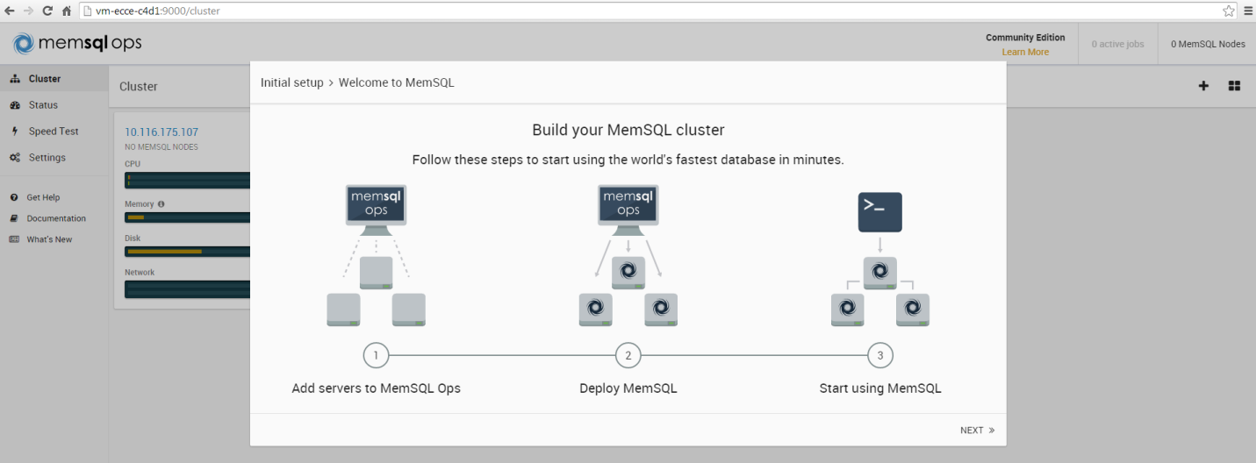

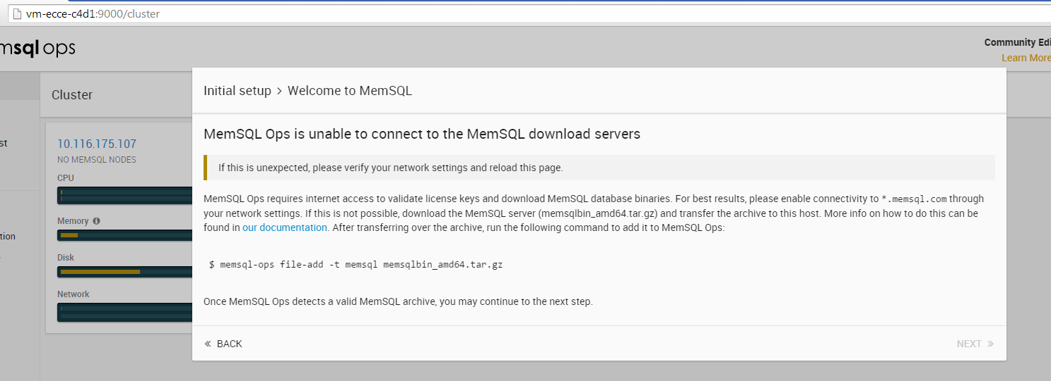

[ root @ dbversitydotcom : /memsql ] memsql-ops file-add -t memsql memsqlbin_amd64.tar
Adding a MemSQL file
Unpacking archive to determine its version
Copying file into MemSQL Ops data directory
Registering file with MemSQL Ops
Adding license file from MemSQL archive to MemSQL Ops
2015-07-17 05:58:42: J92b468 [INFO] Adding a license file for agent Afef126c86f4d408ba284ed004fa055d6
2015-07-17 05:58:42: J92b468 [INFO] Successfully added a license file for agent Afef126c86f4d408ba284ed004fa055d6
Successfully added a MemSQL file with version 4.0.0
[ root @ dbversitydotcom : /memsql ]

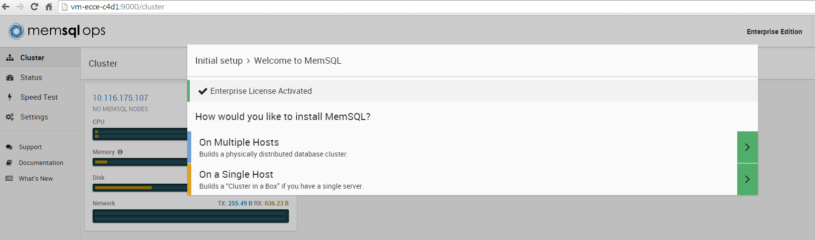

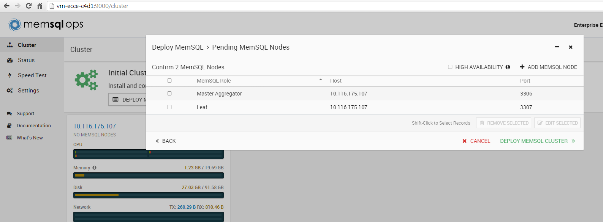

[ root @ dbversitydotcom : /memsql ] ps -ef | grep mysql
root 5696 1 0 Jul05 ? 00:00:00 /bin/sh /usr/bin/mysqld_safe --datadir=/var/lib/mysql --pid-file=/var/lib/mysql/dbversitydotcom.pid
root 5757 27339 0 06:01 pts/1 00:00:00 grep mysql
mysql 5953 5696 0 Jul05 ? 00:13:34 /usr/sbin/mysqld --basedir=/usr --datadir=/var/lib/mysql --plugin-dir=/usr/lib64/mysql/plugin --user=mysql --log-error=/var/lib/mysql/mysqld.log --pid-file=/var/lib/mysql/dbversitydotcom.pid
[ root @ dbversitydotcom : /memsql ]
[ root @ dbversitydotcom : /memsql ]
[ root @ dbversitydotcom : /memsql ] service mysql stop
Shutting down MySQL.. SUCCESS!
[ root @ dbversitydotcom : /memsql ]
[ root @ dbversitydotcom : /memsql ]
[ root @ dbversitydotcom : /memsql ] netstat -nlp | grep 3306
[ root @ dbversitydotcom : /memsql ]
[ root @ dbversitydotcom : /memsql ] memsql-ops status
MemSQL Ops is running with pid 2039 on port 9000.
[ root @ dbversitydotcom : /memsql ]
[ root @ dbversitydotcom : /memsql ]
[ root @ dbversitydotcom : /memsql ] netstat -nlp | grep memsql
tcp 0 0 0.0.0.0:9000 0.0.0.0:* LISTEN 2039/memsql-ops
[ root @ dbversitydotcom : /memsql ]

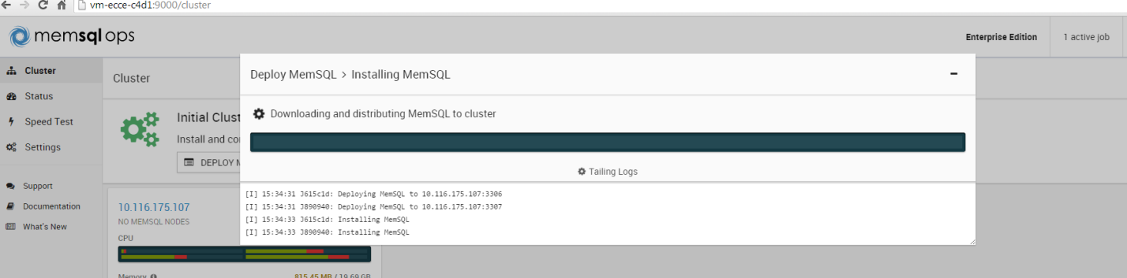

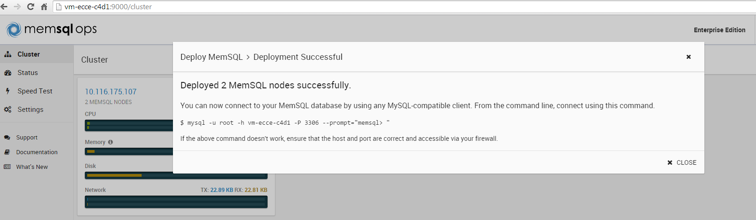

[ root @ dbversitydotcom : /memsql ] netstat -nlp | grep memsql
tcp 0 0 0.0.0.0:3307 0.0.0.0:* LISTEN 7053/memsqld
tcp 0 0 0.0.0.0:9000 0.0.0.0:* LISTEN 2039/memsql-ops
tcp 0 0 0.0.0.0:3306 0.0.0.0:* LISTEN 6655/memsqld
unix 2 [ ACC ] STREAM LISTENING 8862853 7053/memsqld memsql.sock
unix 2 [ ACC ] STREAM LISTENING 8861833 6655/memsqld memsql.sock
unix 2 [ ACC ] STREAM LISTENING 8862707 7055/memsqld @memsql_commandproc_7055
unix 2 [ ACC ] STREAM LISTENING 8838838 6658/memsqld @memsql_commandproc_6658
[ root @ dbversitydotcom : /memsql ]
[ root @ dbversitydotcom : /memsql ]
[ root @ dbversitydotcom : /memsql ]
[ root @ dbversitydotcom : /memsql ]
[ root @ dbversitydotcom : /memsql ]
[ root @ dbversitydotcom : /memsql ] ps -ef | grep memsql
memsql 2039 1 4 05:37 ? 00:01:20 /var/lib/memsql-ops/lib/memsql-ops start -u memsql --port 9000
memsql 6655 1 1 06:04 ? 00:00:00 /var/lib/memsql-ops/data/installs/MIa5e97c3be61648409382d557752251aa/memsqld --defaults-file=/var/lib/memsql-ops/data/installs/MIa5e97c3be61648409382d557752251aa/memsql.cnf --pid-file=/var/lib/memsql-ops/data/installs/MIa5e97c3be61648409382d557752251aa/memsqld.pid --user=memsql
memsql 6658 6655 0 06:04 ? 00:00:00 /var/lib/memsql-ops/data/installs/MIa5e97c3be61648409382d557752251aa/memsqld --defaults-file=/var/lib/memsql-ops/data/installs/MIa5e97c3be61648409382d557752251aa/memsql.cnf --pid-file=/var/lib/memsql-ops/data/installs/MIa5e97c3be61648409382d557752251aa/memsqld.pid --user=memsql
memsql 7053 1 2 06:05 ? 00:00:01 /var/lib/memsql-ops/data/installs/MI9a8271286b5a413d9f54b932cd80a954/memsqld --defaults-file=/var/lib/memsql-ops/data/installs/MI9a8271286b5a413d9f54b932cd80a954/memsql.cnf --pid-file=/var/lib/memsql-ops/data/installs/MI9a8271286b5a413d9f54b932cd80a954/memsqld.pid --user=memsql
memsql 7055 7053 0 06:05 ? 00:00:00 /var/lib/memsql-ops/data/installs/MI9a8271286b5a413d9f54b932cd80a954/memsqld --defaults-file=/var/lib/memsql-ops/data/installs/MI9a8271286b5a413d9f54b932cd80a954/memsql.cnf --pid-file=/var/lib/memsql-ops/data/installs/MI9a8271286b5a413d9f54b932cd80a954/memsqld.pid --user=memsql
root 7428 27339 0 06:06 pts/1 00:00:00 grep memsql
[ root @ dbversitydotcom : /memsql ]
[ root @ dbversitydotcom : /memsql ]
[ root @ dbversitydotcom : /memsql ] mysql -u root -h dbversitydotcom -P 3306 --prompt="memsql> "
Welcome to the MySQL monitor. Commands end with ; or \g.
Your MySQL connection id is 5
Server version: 5.5.8 MemSQL source distribution (compatible; MySQL Enterprise & MySQL Commercial)

Copyright (c) 2000, 2015, Oracle and/or its affiliates. All rights reserved.

Oracle is a registered trademark of Oracle Corporation and/or its
affiliates. Other names may be trademarks of their respective
owners.

Type 'help;' or '\h' for help. Type '\c' to clear the current input statement.

memsql>
memsql>
memsql> show databases;
+--------------------+
| Database |
+--------------------+
| information_schema |
| memsql |
| sharding |
+--------------------+
3 rows in set (0.00 sec)

memsql> select * from information_schema.processlist where info is not null;
+----+-------------+-----------------------------------+--------------------+---------+------+-----------------------------------+---------------------------------------------------------------------+---------+-------------------+----------------+----------------------+-------+
| ID | USER | HOST | DB | COMMAND | TIME | STATE | INFO | PLAN_ID | TRANSACTION_STATE | ROW_LOCKS_HELD | PARTITION_LOCKS_HELD | EPOCH |
+----+-------------+-----------------------------------+--------------------+---------+------+-----------------------------------+---------------------------------------------------------------------+---------+-------------------+----------------+----------------------+-------+
| 23 | root | dbversitydotcom.nam.nsroot.net:12945 | information_schema | Query | 0 | Dropping leaf partition databases | DROP DATABASE IF EXISTS `dbspeedtest` | NULL | NULL | 0 | 0 | NULL |
| 8 | distributed | dbversitydotcom.nam.nsroot.net:5009 | dbspeedtest | Query | 52 | | MEMSQL REPLICATION START | NULL | NULL | 0 | 0 | NULL |
| 5 | root | dbversitydotcom.nam.nsroot.net:2449 | NULL | Query | 24 | executing | select * from information_schema.processlist where info is not null | 2 | NULL | 0 | 0 | 49437 |
| 3 | distributed | dbversitydotcom.nam.nsroot.net:145 | sharding | Query | 160 | | MEMSQL REPLICATION START | NULL | NULL | 0 | 0 | NULL |
+----+-------------+-----------------------------------+--------------------+---------+------+-----------------------------------+---------------------------------------------------------------------+---------+-------------------+----------------+----------------------+-------+
4 rows in set (24.88 sec)

memsql>

Speed Test :

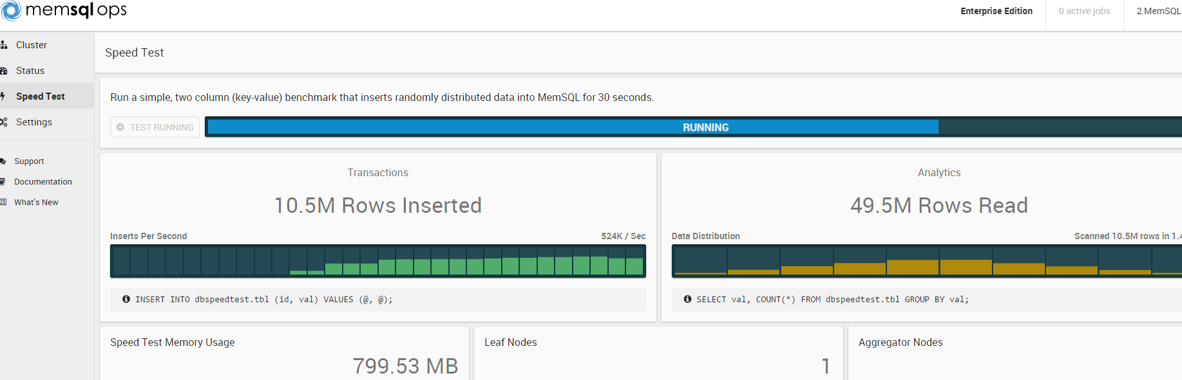

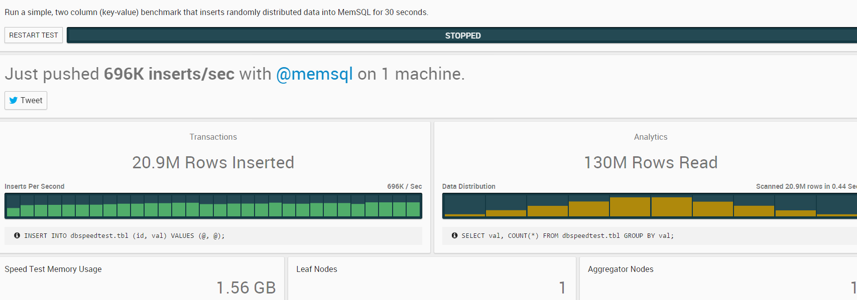

Settings :

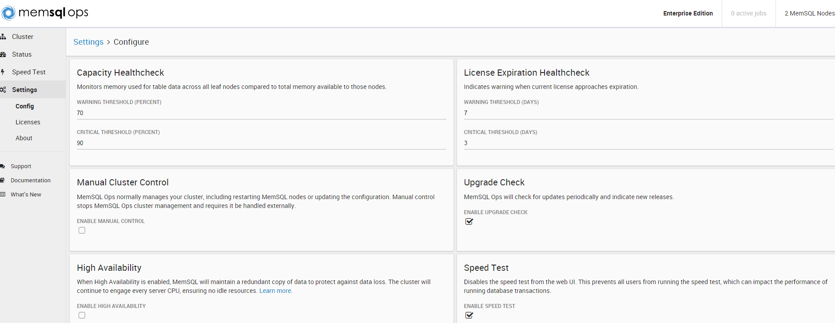

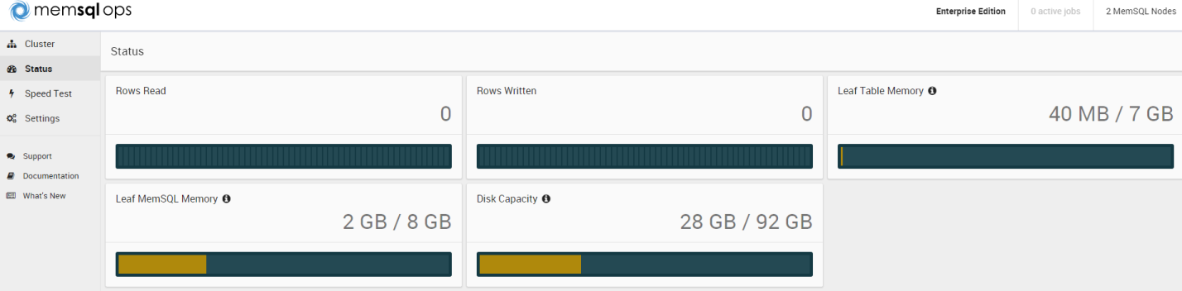

[ root @ dbversitydotcom : /memsql ] ps -ef | grep memsql
memsql 2039 1 6 05:37 ? 00:02:45 /var/lib/memsql-ops/lib/memsql-ops start -u memsql --port 9000
memsql 6655 1 5 06:04 ? 00:01:00 /var/lib/memsql-ops/data/installs/MIa5e97c3be61648409382d557752251aa/memsqld --defaults-file=/var/lib/memsql-ops/data/installs/MIa5e97c3be61648409382d557752251aa/memsql.cnf --pid-file=/var/lib/memsql-ops/data/installs/MIa5e97c3be61648409382d557752251aa/memsqld.pid --user=memsql
memsql 6658 6655 0 06:04 ? 00:00:00 /var/lib/memsql-ops/data/installs/MIa5e97c3be61648409382d557752251aa/memsqld --defaults-file=/var/lib/memsql-ops/data/installs/MIa5e97c3be61648409382d557752251aa/memsql.cnf --pid-file=/var/lib/memsql-ops/data/installs/MIa5e97c3be61648409382d557752251aa/memsqld.pid --user=memsql
memsql 7053 1 7 06:05 ? 00:01:29 /var/lib/memsql-ops/data/installs/MI9a8271286b5a413d9f54b932cd80a954/memsqld --defaults-file=/var/lib/memsql-ops/data/installs/MI9a8271286b5a413d9f54b932cd80a954/memsql.cnf --pid-file=/var/lib/memsql-ops/data/installs/MI9a8271286b5a413d9f54b932cd80a954/memsqld.pid --user=memsql
memsql 7055 7053 0 06:05 ? 00:00:00 /var/lib/memsql-ops/data/installs/MI9a8271286b5a413d9f54b932cd80a954/memsqld --defaults-file=/var/lib/memsql-ops/data/installs/MI9a8271286b5a413d9f54b932cd80a954/memsql.cnf --pid-file=/var/lib/memsql-ops/data/installs/MI9a8271286b5a413d9f54b932cd80a954/memsqld.pid --user=memsql
root 10293 27339 0 06:23 pts/1 00:00:00 grep memsql
[ root @ dbversitydotcom : /memsql ]
[ root @ dbversitydotcom : /memsql ]
[ root @ dbversitydotcom : /memsql ] cat /var/lib/memsql-ops/data/installs/MIa5e97c3be61648409382d557752251aa/memsql.cnf
; ------------------------------------------------------------------
; THIS CONFIGURATION FILE IS MANAGED BY MEMSQL OPS
; MemSQL Ops controls the data in this file. Please be careful
; when editing it.
; For more information contact support@memsql.com
; ------------------------------------------------------------------
[server]
basedir = .
bind_address = 0.0.0.0
core_file
default_partitions_per_leaf = 4
durability = on
lc_messages_dir = ./share
lock_wait_timeout = 60
max_connections = 100000
snapshot_trigger_size = 256m
socket = memsql.sock
tmpdir = .
transaction_buffer = 64m
; ------------------------------------------------------------------
; MEMSQL OPS VARIABLES
;
; Variables below this header are controlled by MemSQL Ops.
; Please do not edit any of these values directly.
; ------------------------------------------------------------------
master_aggregator
port = 3306
[ root @ dbversitydotcom : /memsql ]
[ root @ dbversitydotcom : /memsql ]
[ root @ dbversitydotcom : /memsql ] cat /var/lib/memsql-ops/data/installs/MI9a8271286b5a413d9f54b932cd80a954/memsql.cnf
; ------------------------------------------------------------------
; THIS CONFIGURATION FILE IS MANAGED BY MEMSQL OPS
; MemSQL Ops controls the data in this file. Please be careful
; when editing it.
; For more information contact support@memsql.com
; ------------------------------------------------------------------
[server]
basedir = .
bind_address = 0.0.0.0
core_file
durability = on
lc_messages_dir = ./share
lock_wait_timeout = 60
max_connections = 100000
snapshot_trigger_size = 256m
socket = memsql.sock
tmpdir = .
transaction_buffer = 64m
; ------------------------------------------------------------------
; MEMSQL OPS VARIABLES
;
; Variables below this header are controlled by MemSQL Ops.
; Please do not edit any of these values directly.
; ------------------------------------------------------------------
port = 3307
[ root @ dbversitydotcom : /memsql ]
[ root @ dbversitydotcom : /memsql ]

[ root @ dbversitydotcom : /memsql ]
[ root @ dbversitydotcom : /memsql ] ll -lthr /var/lib/memsql-ops/data/installs/MIa5e97c3be61648409382d557752251aa/
total 7.1M
drwxr-xr-x 2 memsql memsql 4.0K May 20 02:52 share
-rwxr-xr-x 1 memsql memsql 905 May 20 02:52 service
drwxr-xr-x 3 memsql memsql 4.0K May 20 02:52 objdir
-rwxr-xr-x 1 memsql memsql 12K May 20 02:52 check_system
-rw-r--r-- 1 memsql memsql 33K May 20 02:52 redist_licenses.txt
drwxr-xr-x 2 memsql memsql 4.0K May 20 02:52 redist_licenses
-rw-r--r-- 1 memsql memsql 338 May 20 02:52 LICENSE
-rwxr-xr-x 1 memsql memsql 7.0M May 20 02:53 memsqld
drwxr-xr-x 3 memsql memsql 4.0K Jul 17 06:04 utils
drwxr-xr-x 9 memsql memsql 4.0K Jul 17 06:04 lib
-rw-r--r-- 1 memsql memsql 888 Jul 17 06:04 memsql.cnf
-rw-r--r-- 1 memsql memsql 4 Jul 17 06:04 memsqld.pid
drwxr-xr-x 2 memsql memsql 4.0K Jul 17 06:04 tracelogs
drwxr-xr-x 5 memsql memsql 4.0K Jul 17 06:04 data
drwxr-xr-x 49 memsql memsql 4.0K Jul 17 06:07 plancache
[ root @ dbversitydotcom : /memsql ]
[ root @ dbversitydotcom : /memsql ]
[ root @ dbversitydotcom : /memsql ] ll -lhtr /var/lib/memsql-ops/data/installs/MI9a8271286b5a413d9f54b932cd80a954
total 7.1M
drwxr-xr-x 2 memsql memsql 4.0K May 20 02:52 share
-rwxr-xr-x 1 memsql memsql 905 May 20 02:52 service
drwxr-xr-x 3 memsql memsql 4.0K May 20 02:52 objdir
-rwxr-xr-x 1 memsql memsql 12K May 20 02:52 check_system
-rw-r--r-- 1 memsql memsql 33K May 20 02:52 redist_licenses.txt
drwxr-xr-x 2 memsql memsql 4.0K May 20 02:52 redist_licenses
-rw-r--r-- 1 memsql memsql 338 May 20 02:52 LICENSE
-rwxr-xr-x 1 memsql memsql 7.0M May 20 02:53 memsqld
drwxr-xr-x 3 memsql memsql 4.0K Jul 17 06:04 utils
drwxr-xr-x 9 memsql memsql 4.0K Jul 17 06:04 lib
lrwxrwxrwx 1 memsql memsql 68 Jul 17 06:04 MIa5e97c3be61648409382d557752251aa -> /var/lib/memsql-ops/data/installs/MIa5e97c3be61648409382d557752251aa
-rw-r--r-- 1 memsql memsql 838 Jul 17 06:05 memsql.cnf
-rw-r--r-- 1 memsql memsql 4 Jul 17 06:05 memsqld.pid
drwxr-xr-x 2 memsql memsql 4.0K Jul 17 06:05 tracelogs
drwxr-xr-x 5 memsql memsql 4.0K Jul 17 06:05 data
drwxr-xr-x 53 memsql memsql 4.0K Jul 17 06:07 plancache
[ root @ dbversitydotcom : /memsql ]

[ root @ dbversitydotcom : /memsql ] mysql -u root -h dbversitydotcom -P 3306 --prompt="memsql> "
Welcome to the MySQL monitor. Commands end with ; or \g.
Your MySQL connection id is 26
Server version: 5.5.8 MemSQL source distribution (compatible; MySQL Enterprise & MySQL Commercial)

Copyright (c) 2000, 2015, Oracle and/or its affiliates. All rights reserved.

Oracle is a registered trademark of Oracle Corporation and/or its
affiliates. Other names may be trademarks of their respective
owners.

Type 'help;' or '\h' for help. Type '\c' to clear the current input statement.

memsql>
memsql> show aggregators;
+-----------+------+--------+--------------------+------------------------------+-------------------+
| Host | Port | State | Opened_Connections | Average_Roundtrip_Latency_ms | Master_Aggregator |
+-----------+------+--------+--------------------+------------------------------+-------------------+
| 127.0.0.1 | 3306 | online | 0 | NULL | 1 |
+-----------+------+--------+--------------------+------------------------------+-------------------+
1 row in set (0.00 sec)

memsql> SHOW REPLICATION STATUS;
+--------+----------+-----------+----------------+------------------------------+-----------+-----------------+-------------+----------------+---------------+--------------+
| Role | Database | MasterURI | MasterPosition | SlaveURI | Connected | NetworkPosition | SlaveState | ReplayPosition | MasterCommits | SlaveCommits |
+--------+----------+-----------+----------------+------------------------------+-----------+-----------------+-------------+----------------+---------------+--------------+
| master | sharding | NULL | 0:564 | 10.xx.xx.11:3307/sharding | yes | 0:564 | replicating | 0:564 | 13 | 13 |
+--------+----------+-----------+----------------+------------------------------+-----------+-----------------+-------------+----------------+---------------+--------------+
1 row in set (0.00 sec)

memsql>
memsql> select * from information_schema.processlist where info is not null order by time desc;
+----+-------------+-----------------------------------+----------+---------+------+-----------+----------------------------------------------------------------------------------------+---------+-------------------+----------------+----------------------+-------+
| ID | USER | HOST | DB | COMMAND | TIME | STATE | INFO | PLAN_ID | TRANSACTION_STATE | ROW_LOCKS_HELD | PARTITION_LOCKS_HELD | EPOCH |
+----+-------------+-----------------------------------+----------+---------+------+-----------+----------------------------------------------------------------------------------------+---------+-------------------+----------------+----------------------+-------+
| 3 | distributed | dbversitydotcom.nam.nsroot.net:145 | sharding | Query | 1555 | | MEMSQL REPLICATION START | NULL | NULL | 0 | 0 | NULL |
| 26 | root | dbversitydotcom.nam.nsroot.net:56721 | NULL | Query | 3 | executing | select * from information_schema.processlist where info is not null order by time desc | 3 | NULL | 0 | 0 | 99487 |
+----+-------------+-----------------------------------+----------+---------+------+-----------+----------------------------------------------------------------------------------------+---------+-------------------+----------------+----------------------+-------+
2 rows in set (3.45 sec)

memsql>

[ root @ dbversitydotcom : /memsql ] mysql -u root -h dbversitydotcom -P 3306 --prompt="memsql> "
Welcome to the MySQL monitor. Commands end with ; or \g.
Your MySQL connection id is 35
Server version: 5.5.8 MemSQL source distribution (compatible; MySQL Enterprise & MySQL Commercial)

Copyright (c) 2000, 2015, Oracle and/or its affiliates. All rights reserved.

Oracle is a registered trademark of Oracle Corporation and/or its
affiliates. Other names may be trademarks of their respective
owners.

Type 'help;' or '\h' for help. Type '\c' to clear the current input statement.

memsql>
memsql>
memsql> SHOW STATUS;
+-------------------------------------+----------------------------------+
| Variable_name | Value |
+-------------------------------------+----------------------------------+
| Aborted_clients | 1 |
| Aborted_connects | 9 |
| Bytes_received | 265185393 |
| Bytes_sent | 990391286 |
| Connections | 35 |
| Max_used_connections | 22 |
| Queries | 58834 |
| Questions | 58834 |
| Threads_cached | 1 |
| Threads_connected | 21 |
| Threads_created | 22 |
| Threads_running | 2 |
| Uptime | 4228 |
| Aggregator_id | 1 |
| Seconds_until_expiration | 1675313 |
| License_key | 65525960351a46189c7c54e8c9e00fe6 |
| License_type | enterprise |
| Maximum_cluster_capacity | 18446744073709551615 MB |
| Used_cluster_capacity | 15744 MB |
| Query_compilations | 6 |
| Query_compilation_failures | 0 |
| GCed_versions_last_sweep | 0 |
| Average_garbage_collection_duration | 0 ms |
| Total_server_memory | 382.5 MB |
| Loaded_plans_virtual_memory | 2.0 MB |
| Malloc_active_memory | 365.1 MB |
| Malloc_cumulative_memory | 410.0 (+0.0) MB |
| Alloc_variable_cached_buffers | 4.9 MB |
| Ssl_accept_renegotiates | 0 |
| Ssl_accepts | 0 |
| Ssl_callback_cache_hits | 0 |
| Ssl_client_connects | 0 |
| Ssl_connect_renegotiates | 0 |
| Ssl_ctx_verify_depth | 18446744073709551615 |
| Ssl_ctx_verify_mode | 0 |
| Ssl_default_timeout | 0 |
| Ssl_finished_accepts | 0 |
| Ssl_finished_connects | 0 |
| Ssl_session_cache_hits | 0 |
| Ssl_session_cache_misses | 0 |
| Ssl_session_cache_overflows | 0 |
| Ssl_session_cache_size | 20480 |
| Ssl_session_cache_timeouts | 0 |
| Ssl_sessions_reused | 0 |
| Ssl_used_session_cache_entries | 0 |
| Ssl_verify_depth | 0 |
| Ssl_verify_mode | 0 |
| Ssl_cipher | |
| Ssl_cipher_list | |
| Ssl_version | |
| Ssl_session_cache_mode | SERVER |
+-------------------------------------+----------------------------------+
51 rows in set (0.00 sec)

memsql> SELECT @@GLOBAL.redundancy_level;
+---------------------------+
| @@GLOBAL.redundancy_level |
+---------------------------+
| 1 |
+---------------------------+
1 row in set (0.00 sec)

memsql> SHOW REBALANCE STATUS ON db ;
+------------------+---------+----------------+-------------+-------+---------+--------------+
| Action | Ordinal | Target_Host | Target_Port | Phase | Status | Running_Time |
+------------------+---------+----------------+-------------+-------+---------+--------------+
| CREATE PARTITION | 0 | 10.xx.xx.11 | 3307 | 1 | success | 995 |
| CREATE PARTITION | 1 | 10.xx.xx.11 | 3307 | 1 | success | 995 |
| CREATE PARTITION | 2 | 10.xx.xx.11 | 3307 | 1 | success | 995 |
| CREATE PARTITION | 3 | 10.xx.xx.11 | 3307 | 1 | success | 995 |
+------------------+---------+----------------+-------------+-------+---------+--------------+
4 rows in set (0.01 sec)

memsql>
memsql> \! hostname -i
10.xx.xx.11
memsql>
memsql> SHOW LEAVES;
+----------------+------+--------------------+-----------+-----------+--------+--------------------+------------------------------+
| Host | Port | Availability_Group | Pair_Host | Pair_Port | State | Opened_Connections | Average_Roundtrip_Latency_ms |
+----------------+------+--------------------+-----------+-----------+--------+--------------------+------------------------------+
| 10.xx.xx.11 | 3307 | 1 | NULL | NULL | online | 60 | 0.396 |
+----------------+------+--------------------+-----------+-----------+--------+--------------------+------------------------------+
1 row in set (0.00 sec)

memsql>
memsql> SHOW AGGREGATORS;
+-----------+------+--------+--------------------+------------------------------+-------------------+
| Host | Port | State | Opened_Connections | Average_Roundtrip_Latency_ms | Master_Aggregator |
+-----------+------+--------+--------------------+------------------------------+-------------------+
| 127.0.0.1 | 3306 | online | 0 | NULL | 1 |
+-----------+------+--------+--------------------+------------------------------+-------------------+
1 row in set (0.00 sec)

memsql>
memsql> exit
Bye
[ root @ dbversitydotcom : /memsql ]
[ root @ dbversitydotcom : /memsql ]
[ root @ dbversitydotcom : /memsql ] memsql-ops --help
usage: memsql-ops ...

LOCAL MEMSQL OPS AGENT MANAGEMENT:
start Start the MemSQL Ops agent.
stop Stop the MemSQL Ops agent.
restart Restart the MemSQL Ops agent.
follow Connect the local MemSQL Ops agent to the primary
agent.
unfollow Disconnect the local MemSQL Ops agent from the primary
agent.
uninstall Uninstall MemSQL Ops from this host and delete all of
its data.
status Check the status of the MemSQL Ops agent.
version Print version information for MemSQL Ops.
agent-id Print the current MemSQL Ops agent ID.
ssl-set-cert Set an SSL certificate that will be used to serve the
web UI through HTTPS.
ssl-disable Disables SSL for MemSQL Ops.

REMOTE MEMSQL OPS AGENT MANAGEMENT:
agent-start Start one or all MemSQL Ops agents in the cluster.
agent-stop Stop one or all MemSQL Ops agents in the cluster.
agent-upgrade Upgrade MemSQL Ops to the newest version.
agent-deploy Deploy a MemSQL Ops agent to a host.
agent-list List MemSQL Ops agents in the cluster.
agent-set-credential
Set the SSH credentials to use for the specified
agent.
agent-uninstall Uninstall a remote MemSQL Ops agent and all of its
data.
agent-ssh Open SSH connections to agents.
agent-get SCP files from agents.
agent-put SCP files to agents.

MEMSQL NODE MANAGEMENT:
memsql-deploy Deploy a MemSQL node.
memsql-list List MemSQL nodes in the cluster.
memsql-start Start a MemSQL node.
memsql-stop Stop a MemSQL node.
memsql-restart Restart a MemSQL node.
memsql-monitor Start monitoring a MemSQL node in MemSQL Ops.
memsql-unmonitor Stop monitoring a MemSQL node.
memsql-update-config
Change a config value for a MemSQL node.
memsql-update-root-password
Update the root password for a MemSQL node.
memsql-path Get the directory where a given MemSQL node is
installed.
memsql-delete Delete a MemSQL node and all of its data.

MEMSQL CLUSTER MANAGEMENT:
cluster-start Start all MemSQL nodes in the cluster.
cluster-stop Stop all MemSQL nodes in the cluster.
cluster-restart Restart all MemSQL nodes in the cluster.
cluster-upgrade Stop, upgrade, and restart all MemSQL nodes in the
cluster.
cluster-enable-high-availability
Enable high availability for the MemSQL cluster.
cluster-manual-control
Enable or disable MemSQL Ops manual control of the
cluster.

MEMSQL LICENSE MANAGEMENT:
license-list List all registered licenses for MemSQL Enterprise
Edition.
license-add Add a license for MemSQL Enterprise Edition. This
license will be deployed to all MemSQL nodes.

MEMSQL BACKUP MANAGEMENT:
database-backup Create a backup of a database in the MemSQL cluster.
database-restore Restore a MemSQL database from a backup.
database-backup-list
List MemSQL backups in the cluster.
database-backup-delete
Delete a MemSQL backup on all nodes.

MEMSQL OPS JOB MANAGEMENT:
job-list List jobs.
job-info Show information about a job.
job-logs View job logs.
job-cancel Cancel a job.
job-wait Wait for a job to finish.

MEMSQL OPS FILE MANAGEMENT:
file-add Add a file that can be used to install MemSQL or
MemSQL Ops.
file-list List files stored in MemSQL Ops.
file-delete Delete a file stored in MemSQL Ops.

MEMSQL OPS SUPERUSER MANAGEMENT:
superuser-list List superusers that can manage MemSQL Ops.
superuser-add Add a superuser that can manage MemSQL Ops.
superuser-delete Delete an existing superuser.

MEMSQL OPS TOOLS:
help Print user manual for MemSQL Ops.
report Generate a report that contains diagnostic information
for MemSQL Ops.

EXAMPLES:
Start MemSQL Ops on this host:
$ memsql-ops start

Check to see if MemSQL Ops is running:
$ memsql-ops status

Stop MemSQL Ops on this host:
$ memsql-ops stop

For more information please visit our online documentation:
http://docs.memsql.com/latest/ops
[ root @ dbversitydotcom : /memsql ]
[ root @ dbversitydotcom : /memsql ]
[ root @ dbversitydotcom : /memsql ]
[ root @ dbversitydotcom : /memsql ] memsql-ops memsql-list
ID Agent Id Process State Cluster State Role Host Port
6DCC03C Afef126 RUNNING CONNECTED MASTER 10.xx.xx.11 3306
F1371BF Afef126 RUNNING CONNECTED LEAF 10.xx.xx.11 3307
[ root @ dbversitydotcom : /memsql ]
[ root @ dbversitydotcom : /memsql ]
[ root @ dbversitydotcom : /memsql ] memsql-ops memsql-path F1371BF
/var/lib/memsql-ops/data/installs/MI9a8271286b5a413d9f54b932cd80a954
[ root @ dbversitydotcom : /memsql ]
[ root @ dbversitydotcom : /memsql ]
[ root @ dbversitydotcom : /memsql ] memsql-ops memsql-path 6DCC03C
/var/lib/memsql-ops/data/installs/MIa5e97c3be61648409382d557752251aa
[ root @ dbversitydotcom : /memsql ]
[ root @ dbversitydotcom : /memsql ]
[ root @ dbversitydotcom : /memsql ] memsql-ops version
Version: 4.0.31
Git SHA: 02d78dc77925eb294bf92e5a6769b8df3da3f5c1
[ root @ dbversitydotcom : /memsql ]

[ root @ dbversitydotcom : /memsql ]
[ root @ dbversitydotcom : /memsql ] memsql-ops memsql-unmonitor
Index ID Agent Id Process State Cluster State Role Host Port
1 6DCC03C Afef126 RUNNING CONNECTED MASTER 10.xx.xx.11 3306
2 F1371BF Afef126 RUNNING CONNECTED LEAF 10.xx.xx.11 3307
Must be in the range 1-2
Select a MemSQL node: 1
2015-07-17 07:29:39: J79e589 [INFO] Stopping monitoring for MemSQL node 6DCC03C6ECF8A8F97026EA4814D91BBC004BBBCB
2015-07-17 07:29:39: J79e589 [INFO] No longer monitoring MemSQL node 6DCC03C6ECF8A8F97026EA4814D91BBC004BBBCB
[ root @ dbversitydotcom : /memsql ]
[ root @ dbversitydotcom : /memsql ] memsql-ops memsql-unmonitor
Index ID Agent Id Process State Cluster State Role Host Port
1 F1371BF Afef126 RUNNING CONNECTED LEAF 10.xx.xx.11 3307
Must be in the range 1-1

Select a MemSQL node: 1
2015-07-17 07:29:51: J7b618a [INFO] Stopping monitoring for MemSQL node F1371BF8DDCF1D603286611CAF7CCA95FDC390F6
2015-07-17 07:29:51: J7b618a [INFO] No longer monitoring MemSQL node F1371BF8DDCF1D603286611CAF7CCA95FDC390F6
[ root @ dbversitydotcom : /memsql ]

-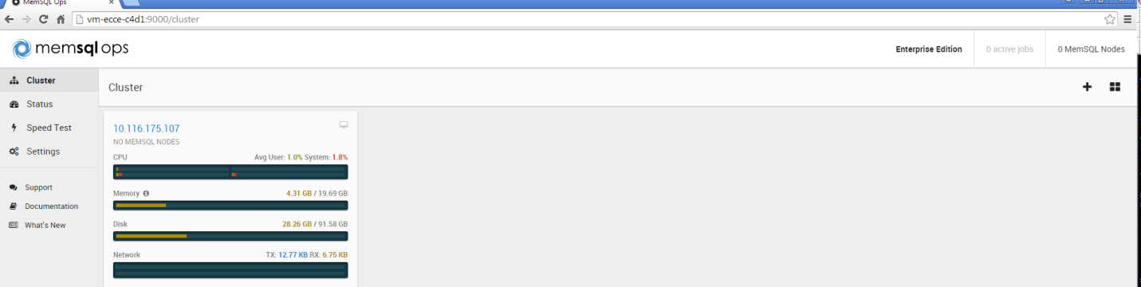

[ root @ dbversitydotcom : /memsql ] memsql-ops memsql-monitor --help
usage: memsql-ops memsql-monitor [--settings-file SETTINGS_FILE] [--async]
[-h HOST] [-P PORT] [-u USER] [-p [PASSWORD]]
[--single-box]

Start monitoring a MemSQL node in MemSQL Ops.

optional arguments:
--settings-file SETTINGS_FILE
A path to a MemSQL Ops settings.conf file. If not set,
we will use the file in the same directory as the
MemSQL Ops binary.
--async If this option is true, we will exit without waiting
for MemSQL Ops to monitor the node.
-h HOST, --host HOST The host for the MemSQL node. If this is not
specified, we will use the local host.
-P PORT, --port PORT The port for the MemSQL node.
-u USER, --user USER The user to use for the MemSQL node.
-p [PASSWORD], --password [PASSWORD]
The password to use for the MemSQL node.
--single-box If this is true, we will not attempt to attach this
MemSQL node to the rest of the cluster.
[ root @ dbversitydotcom : /memsql ]
[ root @ dbversitydotcom : /memsql ]
[ root @ dbversitydotcom : /memsql ]
[ root @ dbversitydotcom : /memsql ] memsql-ops memsql-monitor -h 10.xx.xx.11 -P 3306 --single-box
2015-07-17 07:47:51: J02a977 [INFO] Monitoring MemSQL node at 10.xx.xx.11:3306
2015-07-17 07:47:51: J02a977 [INFO] Now monitoring MemSQL node at 10.xx.xx.11:3306
[ root @ dbversitydotcom : /memsql ]
[ root @ dbversitydotcom : /memsql ]
[ root @ dbversitydotcom : /memsql ] memsql-ops memsql-monitor -h 10.xx.xx.11 -P 3306 --single-box
2015-07-17 07:48:07: J308e3c [INFO] Monitoring MemSQL node at 10.xx.xx.11:3306
2015-07-17 07:48:07: J308e3c [ERROR] Already monitoring MemSQL node with id 6DCC03C6ECF8A8F97026EA4814D91BBC004BBBCB
[ root @ dbversitydotcom : /memsql ]
[ root @ dbversitydotcom : /memsql ]
[ root @ dbversitydotcom : /memsql ] memsql-ops memsql-monitor -h 10.xx.xx.11 -P 3307 --single-box
2015-07-17 07:48:15: J3633d7 [INFO] Monitoring MemSQL node at 10.xx.xx.11:3307
2015-07-17 07:48:15: J3633d7 [INFO] Now monitoring MemSQL node at 10.xx.xx.11:3307
[ root @ dbversitydotcom : /memsql ]
[ root @ dbversitydotcom : /memsql ]
[ root @ dbversitydotcom : /memsql ] memsql-ops memsql-unmonitor
Index ID Agent Id Process State Cluster State Role Host Port
1 6DCC03C Afef126 RUNNING CONNECTED MASTER 10.xx.xx.11 3306
2 F1371BF Afef126 RUNNING CONNECTED SINGLE_BOX 10.xx.xx.11 3307

Select a MemSQL node:
[ root @ dbversitydotcom : /memsql ]

